**IRRIGATION FARMING IN EAST AFRICA.**

Irrigation refers to artificial application/supply of water to support the crop growth. It is mainly carried out in areas that:

* Experience high rates of evaporation.
* Receive low and unreliable rainfall.
* Areas that aim at producing enough food crops.
* The need to support the crops that require greater supply of water.

Irrigation in east Africa is carried out in the following areas:

* Mwea-Tebere scheme (in Kenya)
* Kilombero valley scheme (in Tanzania)
* Ahero Pilot scheme (in Kano plains of Kenya)
* Doho scheme (in Uganda)
* Mobuku scheme (in Uganda)
* Galore scheme (in Tanzania)

**Mwea-Tebere irrigation scheme.**

This scheme is located 96km North East of Nairobi near the foot hills of Mt Kenya at 11600 meters above sea level (380ft).

Water for irrigation is obtained from river **Thiba** and **Nyamindi** which originate from Mt. Kenya.

The major crop grown is **rice.**

The project is made up of three major irrigation blocks i.e. **Mwea, Tebere** and **Thiba.** However, there are also other two minor blocks i.e. **Wamumu** and **Karaba.**

**Aims of establishing Mwea-Tebere Irrigation project.**

* To provide rice and other imports.
* To resettle landless families.
* To develop the area of North Eastern Kenya.
* To provide employment to the people.
* To produce hydro electricity.

**A SKECTH MAP SHOWING THE LOCATION OF MWEA-TEBERE IRRIGATION SCHEME.**

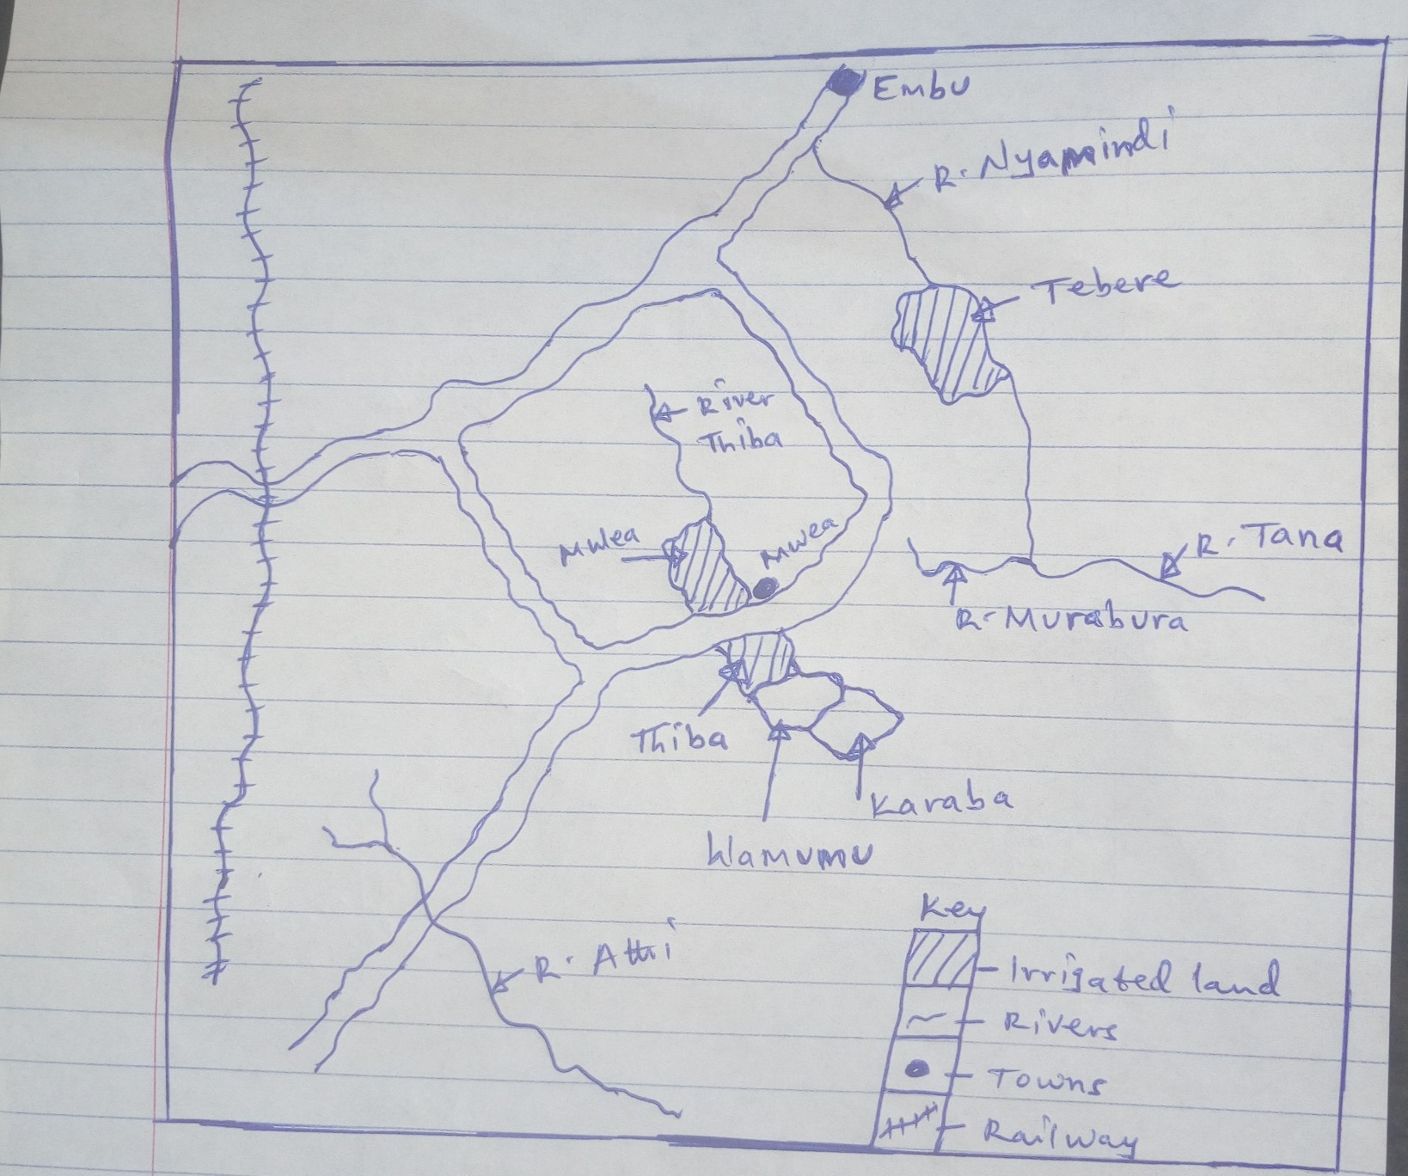

**FACTORS THAT HAVE FAVOURED THE DEVELOPMENT OF MWEA-TEBERE IRRIGATION SCHEME:**

* Presence of vast land for the establishment and expansion of the scheme.
* Gently sloping landscape enables irrigation of the blocks under gravity and for mechanization.
* Fertile black volcanic soils which support rice growing and other crops.
* Plenty of water for irrigation provided by rivers like Thiba and Nyamindi.
* Unreliable rainfall in the area of less than 750mm favored irrigation farming.
* Large sums of capital provided by the government and local investors for purchasing farm inputs and tools.
* Presence of skilled and semi-skilled labor provided by the neighboring communities to work in the scheme.
* Positive attitude of the local people towards the project also favored its establishment and development.
* Favorable government policy of setting up irrigation project in remote areas.
* Improved transport network by roads and railway for transporting crops to the market eg.Kenya-Nyeri railway.

**BENEFITS OF THE PROJECT TO THE PEOPLE OF KENYA:**

* The project has provided employment opportunities to the farmers who earn income to improve their standard of living.
* It has promoted the growth of industries such as rice mills by providing raw materials.
* It has promoted the growth of towns like Embu which provide better social services to the people.
* The project has promoted the development of infrastructure like roads, schools etc which are used by the tenant farmers.
* The tenant farmers have acquired high standards of living due to the secured food and income.
* It is a source of government revenue through taxes paid by the tenant farmers hence leading to development.
* The scheme has encouraged research on crop varieties such as rice and also research on pest and disease control hence improving the yields.
* It is a source of food eg rice for human consumption and for sale.
* It has controlled flooding of rivers like Thiba and Nyamindi thus improved living conditions.
* It is a source of income to farmers through sale of their crops hence improving their standards of living.

**PROBLEMS FACED BY THE FARMERS IN MWEA-TEBERE SCHEME:**

* Pests and diseases destroy the crops hence losses to the farmers.
* Stiff competition from other producing areas hence limiting the market for the crops.
* Price fluctuations in the market leading to unstable farmer’s income.
* Shortage of labor to work in the scheme hence low output.
* Silting of the canals increases the cost of irrigation inform of constant dredging.
* Reduction in soil fertility leading to low yields.
* Harsh weather conditions like hailstorms destroy the crops hence losses to the farmers.

**KILOMBERO VALLEY IRRIGATION SCHEME:**

This scheme is located in southern Tanzania in river Rufigi basin i.e between R.Great Ruaha and R.Kilombero.

Water for irrigation pumped from **R.Great Ruaha.**

**Overhead sprinklers** are used to pump water to the scheme.

The major crop grown is **Sugarcane.**

The scheme was established by the government to open up the remote and unprosperous areas of Southern Tanzania.

**OVERHEAD SPRINKLER.**

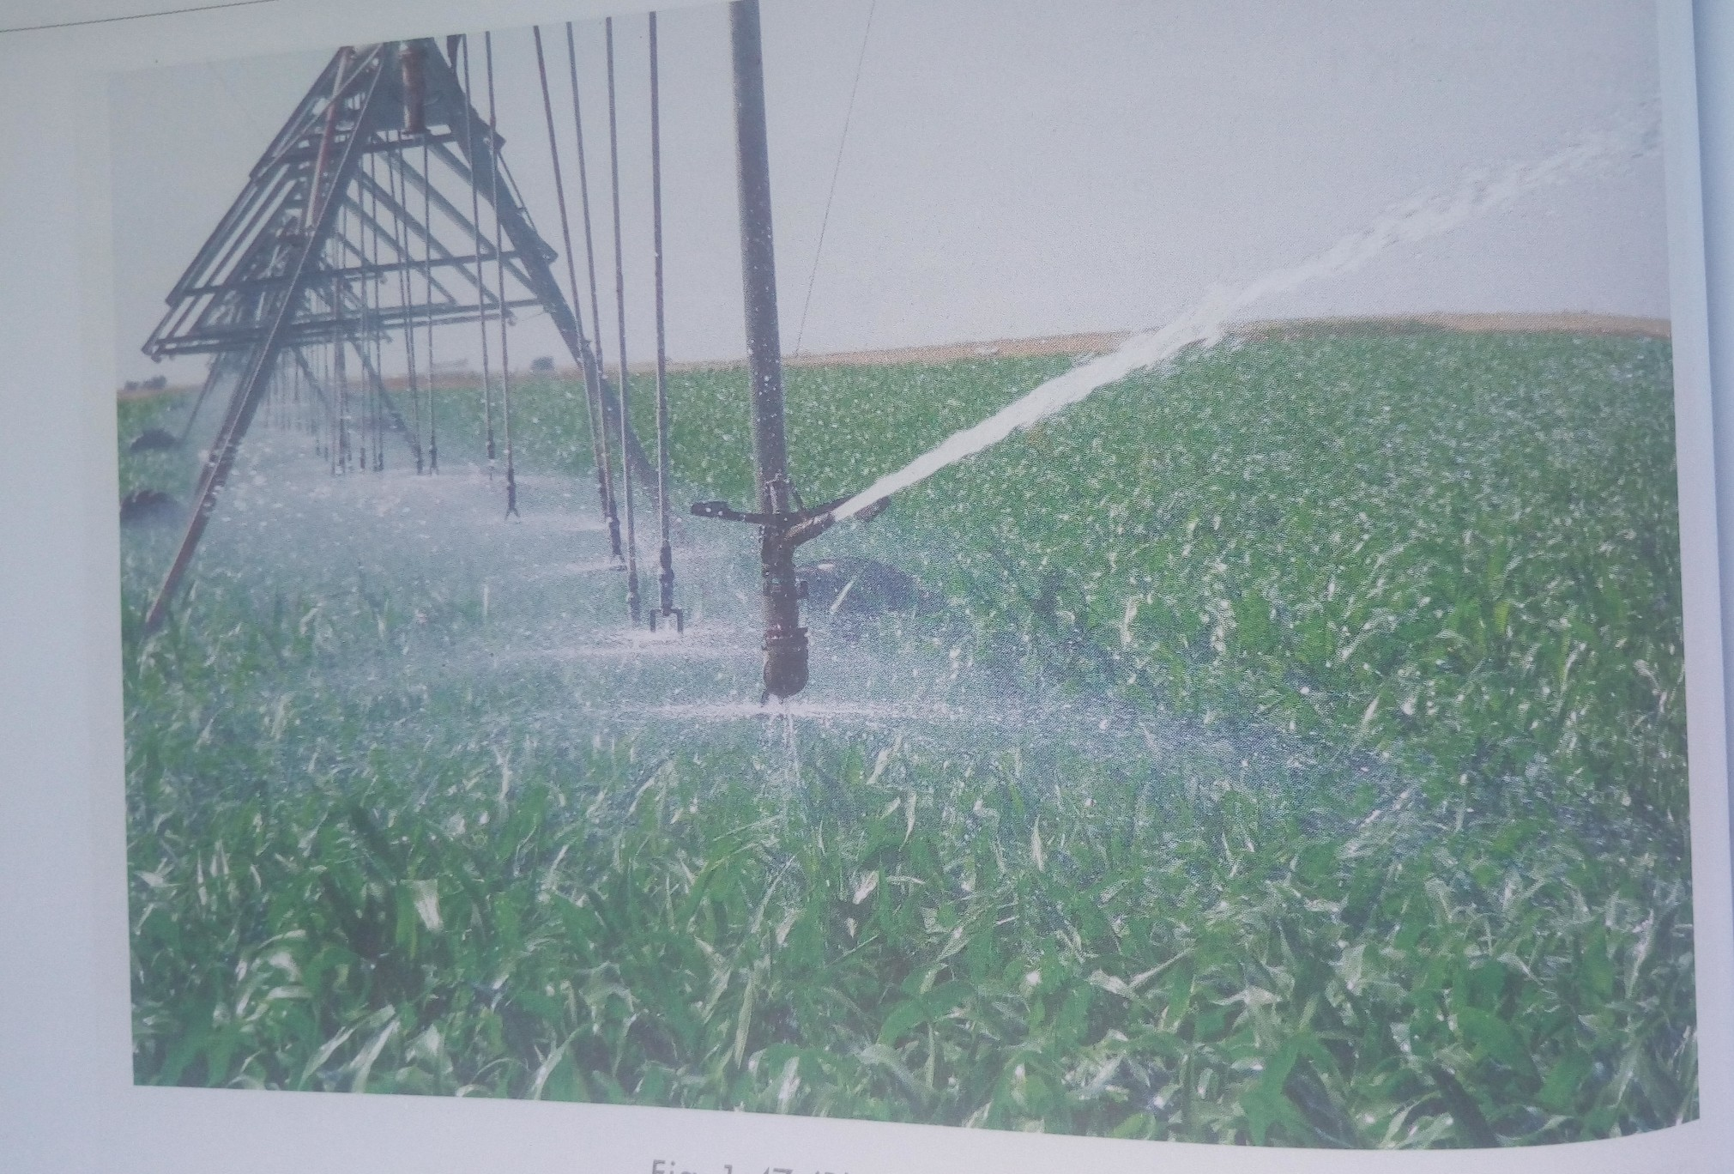

**THE AIMS OF ESTABLISHING THE SCHEME:**

* To open up remote areas of Southern Tanzania.
* To produce sugar through the kilombero sugar company.
* To control river flooding and hence provide fertile land for farming.
* To diversify the economy of the area especially the small farmers known as out growers.

**A SKECTH MAP OF KILOMBERO VALLEY IRRIGATION SCHEME SHOWING RIVERS, TOWNS AND IRRIGATED AREA:**

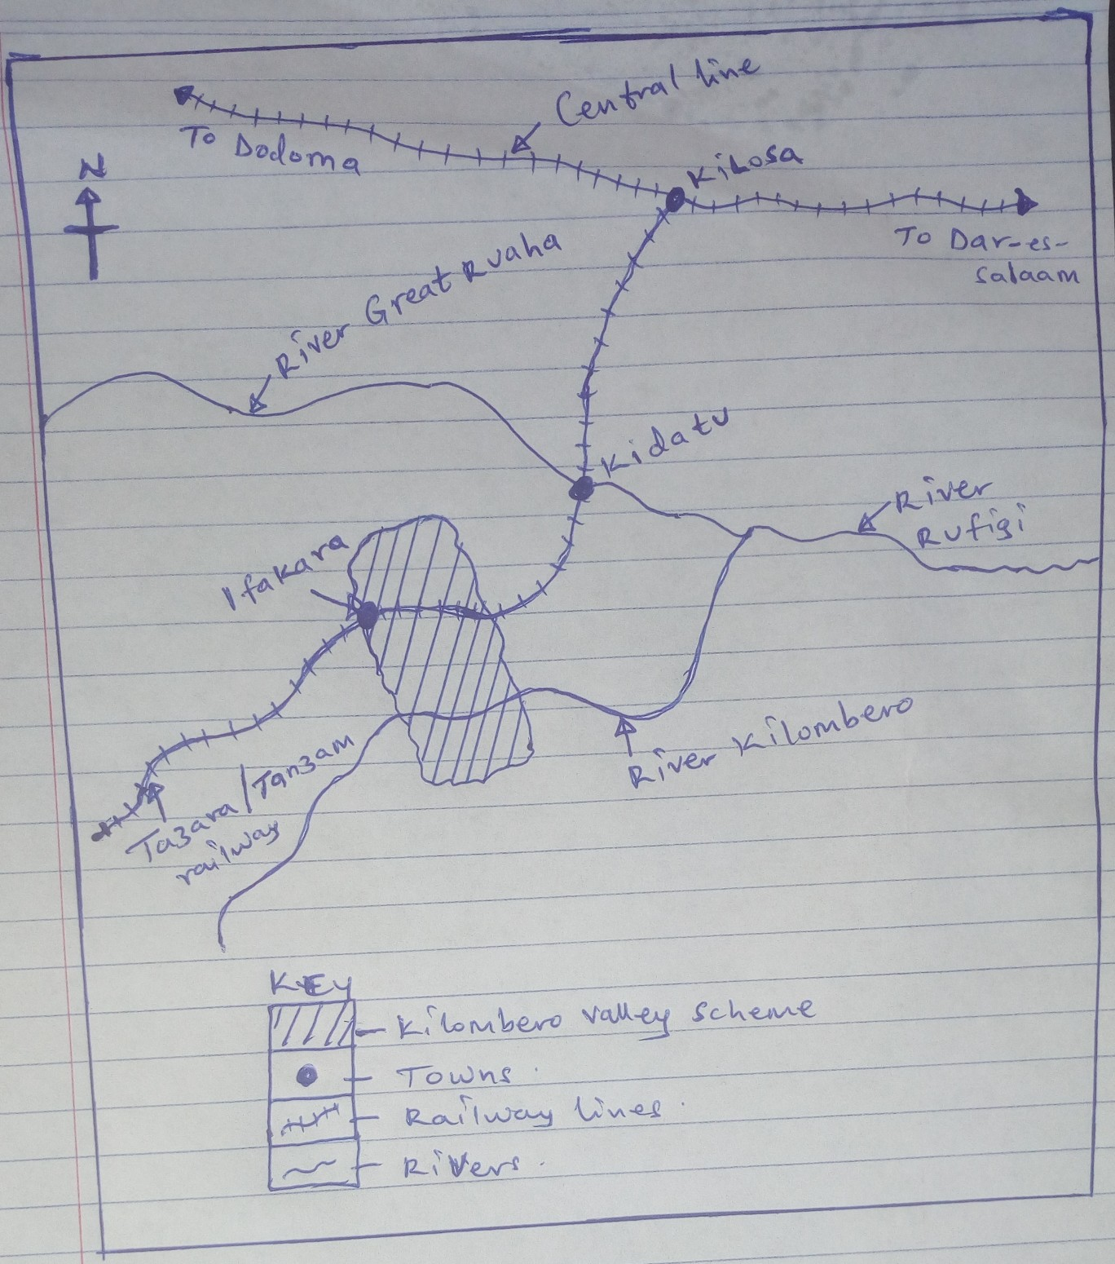

**FACTORS FAVOURING THE LOCATION OF KILOMBERO VALLEY IRRIGATION SCHEME: (factors favoring sugarcane growing).**

**Physical factors/conditions;**

* Presence of vast land with sparse population encouraged large scale sugarcane growing in the area.
* Presence of fertile soils in the kilombero valley which ensured high output.
* Gently sloping landscape favoring the use of machines and irrigation under gravity.
* Reliable water supply provided by R.Great Ruaha and R.Kilombero for irrigation purposes.
* Heavy rainfall which is well distributed throughout the year for the growth of sugarcane.
* Hot temperatures of over 20 degrees celicius facilitate the growth of sugarcane.

**Human factors/conditions;**

* Large sums of capital provided by Kilombero Company for buying farm equipments.
* Presence of skilled and semi skilled labor to work in the scheme like harvesting and transportation of sugarcane.
* Ready market for both at home and foreign markets.
* Improved transport network by roads and railways for transportation of the crops to the market.
* Favorable government policy that aimed at developing remote areas of southern Tanzania.
* Advanced levels of technology involving the use of overhead sprinklers.

**IMPORTANCE OF KILOMBERO VALLEY SCHEME TO THE PEOPLE OF TANZANIA.**

* It has provided employment to the people who work in factories and sugarcane plantation and they earn income to improve their standards of living.
* It is a source of government revenue through taxation of the processing factories and workers income and this revenue is used to develop a country.
* The scheme has promoted the development of infrastructure such as roads and railways that pass through the scheme hence facilitating the transportation of the crops to the market.
* Sugar is exported to other countries to earn foreign exchange to the country which is used for development.
* It has promoted international relationship between Tanzania and other countries that import sugar thus promoting peace and stability.
* The scheme has encouraged the development of the out growers due to accessibility to the factories and extension services provided by the scheme such as research.
* The scheme has increased food security as other crops are grown along side sugarcane.
* The scheme has promoted the development of urban centers like Kilosa, Kidatu and Ifakara and these towns provide better social services to the people.

**PROBLEMS FACED BY THE FARMERS IN KILOMBERO SCHEME:**

* Pests and diseases attack and destroy the crops leading to low yields.
* Soil exhaustion due monoculture leading to low sugarcane output.
* Limited labor to work in the scheme due to low population hence low production.
* Inadequate capital to invest in sugarcane plantation leading to low output.
* Price fluctuation in the world market due to over production thus reducing the farmer’s incomes.
* Fire out breaks especially during the dry season destroys the crop hence losses to the farmers.
* Silting of the canals thus increasing the costs of production inform of constant dredging.
* Poorly developed transport network inform of roads and railways hence limiting access to the market centers.
* Salinity of the soils due to excessive evaporation leads to low harvest.
* Competition with other producing areas like Mumias, Muhoroni and Kabira hence reducing the market.

**MEASURES BEING TAKEN TO SOLVE THE PROBLEMS ABOVE:**

* Application of fertilizers to improve on soil fertility and productivity.
* Spraying of the crop to kill pests and diseases.
* Research on sugarcane varieties to increase production and quality.
* Mechanization to solve the problem of labour shortage.
* Constant dredging of canals to control siltation and enable water flow.
* Construction of feeder roads and railways to facilitate the transportation of sugarcane to the market.
* Diversification of the economy to reduce reliance on one activity.
* Acquiring loans from financial institutions like banks to purchase farm inputs like fertilizers, pesticides etc.

**REVISION QUESTIONS:**

(a). Draw a sketch map of kilombero valley irrigation scheme and on it mark and name;

(i). Kilombero scheme

(ii).Towns; Ifakara, Kidatu and Kilosa.

(iii). Rivers; Great Ruaha and Kilombero.

(iv). Railway lines; Tanzam and Central

(b). Describe the conditions that have favored sugarcane growing in Kilombero valley irrigation scheme.

(c). Explain the importance of the scheme to the people of Tanzania.

(d). Outline the problems faced by the farmers on the irrigation scheme.

(e). Outline the steps being taken to solve the problems stated in (d) above.

**AHERO-PILOT SCHEME:**

This scheme is located in western Kenya in the **Kano Plains** along river Nyando.

It obtains its water for irrigation from **River Nyando.**

The major crop grown is **Rice**

It is managed by **National Irrigation Board** **(NIB).**

It covers a total land area of 365000 acres with over 500 farmers.

**GALORE IRRIGATION SCHEME:**

This scheme is located in **River Tana basin** in Tanzania.

The major crop grown is **Cotton.** Other crops include; **groundnuts** and **sugarcane.**

The scheme was established to act as an example on how the arid areas of River Tana could be irrigated for crop production.

**MOBUKU IRRIGATION SCHEME:**

This is an example of a successful irrigation project in Uganda.

It is found on the lower slopes of Mt.Rwenzori (Kasese) where the climate is hot and dry with low rainfall due to the rain shadow effect of the mountain.

Water for irrigation is obtained from **River Sebwe** and **River Mobuku** by use of Canals.

The major crop grown is **Cotton.** Other crops include; **Rice, maize, vegetables** etc.

**AIMS OF ESTABLISHING MOBUKU IRRIGATION SCHEME:**

* To put in place a demonstration project which would improve on the farming methods in the area.
* To make the best use of the dry area through irrigation in order to resettle the Bamba and Bakonjo population.
* To increase food production by growing Rice, maize, vegetables etc.
* To create employment opportunities in the area.

**DOHO IRRIGATION SCHEME:**

This is an example of large scale irrigation irrigation project in Uganda.

It was set up along **River Manafwa in Butaleja district.**

The major crop grown is **Rice.** Other crops include; **maize, cassava** and **millet.**

**AIMS OF ESTABLISHING DOHO IRRIGATION SCHEME:**

* To grow rice on large scale for both domestic and foreign market.
* To create employment in the area and improve people’s standards of living.
* To demonstrate to the farmers the best ways of crop farming such that they adopt them.
* To control flooding of River Manafwa in the area to boost agriculture and settlement.
* To encourage the farmers grow enough food for the area.